WLU FOOTBALL 2005 VANIER CUP CHAMPIONS THE CORD WEEKLY
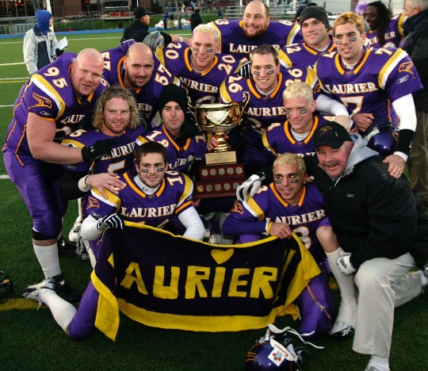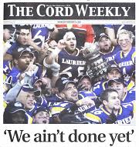
REGULAR SEASON
Game 1: Hawks Trounce Queens
https://core.ac.uk/download/pdf/143684666.pdf
Game 4: Laurier Jumps Mac
https://scholars.wlu.ca/cgi/viewcontent.cgi?article=2181&context=thecord
Game 5: Hawks Win Lopsided Affair (WLU dismantles Waterloo)
https://scholars.wlu.ca/cgi/viewcontent.cgi?article=2182&context=thecord
Game 6: Hawks Plough Over Western
https://scholars.wlu.ca/cgi/viewcontent.cgi?article=2183&context=thecord
Game 7: Golden Hawks Clinch Top Spot in OUA in drubbing of York Lions
https://scholars.wlu.ca/cgi/viewcontent.cgi?article=2184&context=thecord
Game 8: Hawks Outgun Guelph
https://scholars.wlu.ca/cgi/viewcontent.cgi?article=2185&context=thecord
VANIER CUP
1.Playoff Preview
https://scholars.wlu.ca/cgi/viewcontent.cgi?article=2186&context=thecord
2.We Ain’t Done Yet (Yates Cup victory over Western)
https://scholars.wlu.ca/cgi/viewcontent.cgi?article=2188&context=thecord
3.And Now the Vanier (Uteck Bowl victory over Acadia)
https://scholars.wlu.ca/cgi/viewcontent.cgi?article=2189&context=thecord
5.The End of an Era
https://scholars.wlu.ca/cgi/viewcontent.cgi?article=2190&context=thecord
6.Mission Accomplished
https://scholars.wlu.ca/cgi/viewcontent.cgi?article=2191&context=thecord
7.2005 Vanier Cup Champions: A Team of Destiny
https://thecord.ca/vanier-cup-anniversary/
VANIER CUP ARTICLES (other news media)
1.https://www.cbc.ca/sports/football/laurier-wins-vanier-cup-thriller-1.547167
2. https://campusmagazine.wlu.ca/2015/winter/campus-news/2005-vanier-cup-champs-honoured-at-homecoming.html
3. https://www.insidehalton.com/community-story/2898173-luciani-catch-key-in-laurier-s-vanier-cup-win/
4. https://presto-en.usports.ca/sports/fball/vanier_stats/vanier_stats05
5. https://theprovince.com/sports/university/vanier-cup-countdown-2005-wilfrid-laurier-vs-saskatchewan
6. https://www.thespec.com/sports/2016/12/03/the-day-the-hawks-flew-off-as-champions.html

