WLU FOOTBALL 2005 VANIER CUP CHAMPIONS

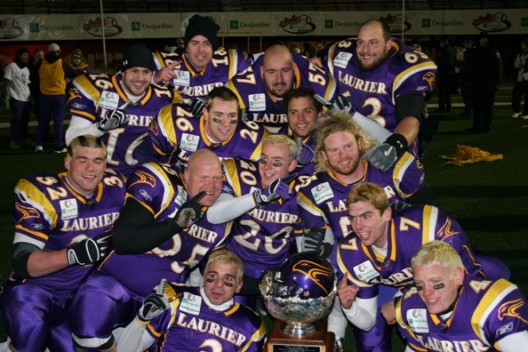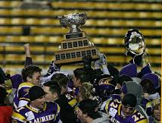

REGULAR SEASON (8 – 0)
1.WLU 45 @ Queens 0
https://www.laurierathletics.com/createarticle.php?ID=2288&sport=MFOOT
https://www.laurierathletics.com/varsityathletics/gamestats.php?sport=MFOOT&year=&gameid=4787

2.WLU 47 Windsor 24
https://www.laurierathletics.com/createarticle.php?ID=2292&sport=MFOOT
https://www.laurierathletics.com/varsityathletics/gamestats.php?sport=MFOOT&year=&gameid=4788

3.WLU 21 @ Ottawa 14
https://www.laurierathletics.com/createarticle.php?ID=2304&sport=MFOOT
https://www.laurierathletics.com/varsityathletics/gamestats.php?sport=MFOOT&year=&gameid=4789

4.WLU 33 McMaster 26
https://www.laurierathletics.com/createarticle.php?ID=2320&sport=MFOOT
https://www.laurierathletics.com/varsityathletics/gamestats.php?sport=MFOOT&year=&gameid=4790

5.WLU 49 Waterloo 4
https://www.laurierathletics.com/createarticle.php?ID=2336&sport=MFOOT
https://www.laurierathletics.com/varsityathletics/gamestats.php?sport=MFOOT&year=&gameid=4791

6.WLU 32 @ Western 17
https://www.laurierathletics.com/createarticle.php?ID=2350&sport=MFOOT
https://www.laurierathletics.com/varsityathletics/gamestats.php?sport=MFOOT&year=&gameid=4792

7.WLU 56 York 3
https://www.laurierathletics.com/createarticle.php?ID=2367&sport=MFOOT
https://www.laurierathletics.com/varsityathletics/gamestats.php?sport=MFOOT&year=&gameid=4793

8.WLU 47 @ Guelph 26
https://www.laurierathletics.com/createarticle.php?ID=2386&sport=MFOOT
https://www.laurierathletics.com/varsityathletics/gamestats.php?sport=MFOOT&year=&gameid=4794

PLAYOFFS (4 – 0)
1.OUA Semis WLU 43 McMaster 21
https://www.laurierathletics.com/createarticle.php?ID=2417&sport=MFOOT
https://www.laurierathletics.com/varsityathletics/gamestats.php?sport=MFOOT&year=&gameid=5075

2.OUA Finals (Yates Cup) WLU 29 Western 11
https://www.laurierathletics.com/createarticle.php?ID=2436&sport=MFOOT
https://www.laurierathletics.com/varsityathletics/gamestats.php?sport=MFOOT&year=&gameid=5080

3.National Semis (Uteck Bowl) WLU 31 Acadia 10
https://www.laurierathletics.com/createarticle.php?ID=2448&sport=MFOOT
https://www.laurierathletics.com/varsityathletics/gamestats.php?sport=MFOOT&year=&gameid=5081

4.National Championship (Vanier Cup) WLU 24 Saskatchewan 23
https://www.laurierathletics.com/createarticle.php?ID=2471&sport=MFOOT
https://www.laurierathletics.com/varsityathletics/gamestats.php?sport=MFOOT&year=&gameid=5083

